Calculate marks and average of students
Objective:
To find the marks and average of students in a particular subject in a class.
Complexity level:
- Easy
Business Scenario:
- ABC College is a private, co-educational engineering college located in XXX.
- ABC College was originally established on July 8, 1985.Over the years the college expanded its admission program to include women, in 1992.Today, the college thriving multi-cultural institution of higher learning that continues to emphasize its commitment to the local community.
- The college offers undergraduate and graduate programs, including masters and doctoral degrees and certificates of advanced graduate study.
- There are two sections in master degree of computer science department, sample data for section-A has 5 students and sample data for section-B has 7 students.
Data set for Section-A
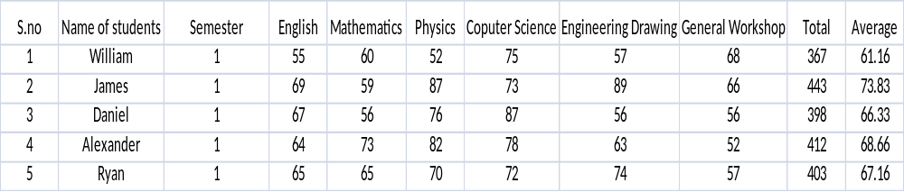
Data set for Section-B
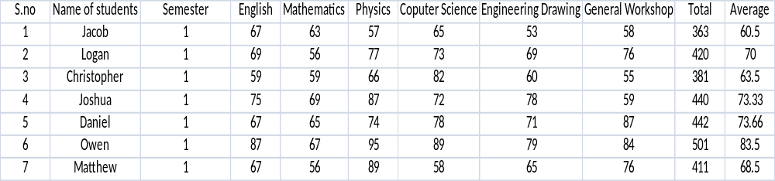
Problem Statement:
- Write an algorithm to find out the average of marks obtain by students in mathematics.
- Write an algorithm to find out the students who scored maximum marks in chemistry.
Expectation outcomes:
Draw the flowchart to find out the average of marks of students in a particular subject in a class.
Tools:
- Open office for designing the flow chart.
Reference URL:
- Grade point average. (n.d.). WordNet2.0 Retrieved 3 October 2011, from Dictionary.com website: http://dictionary.reference.com/browse/grade point average.
- Pierson, George (1983). "C. Undergraduate Studies: Yale College". A Yale Book of Numbers. Historical Statistics of the College and University 1701 - 1976. New Haven: Yale Office of Institutional Research. p. 310.
- Postman, Neil (1992). Technopoly the Surrender of Culture to Technology. New York: Alfred A. Knopf. p. 13.

